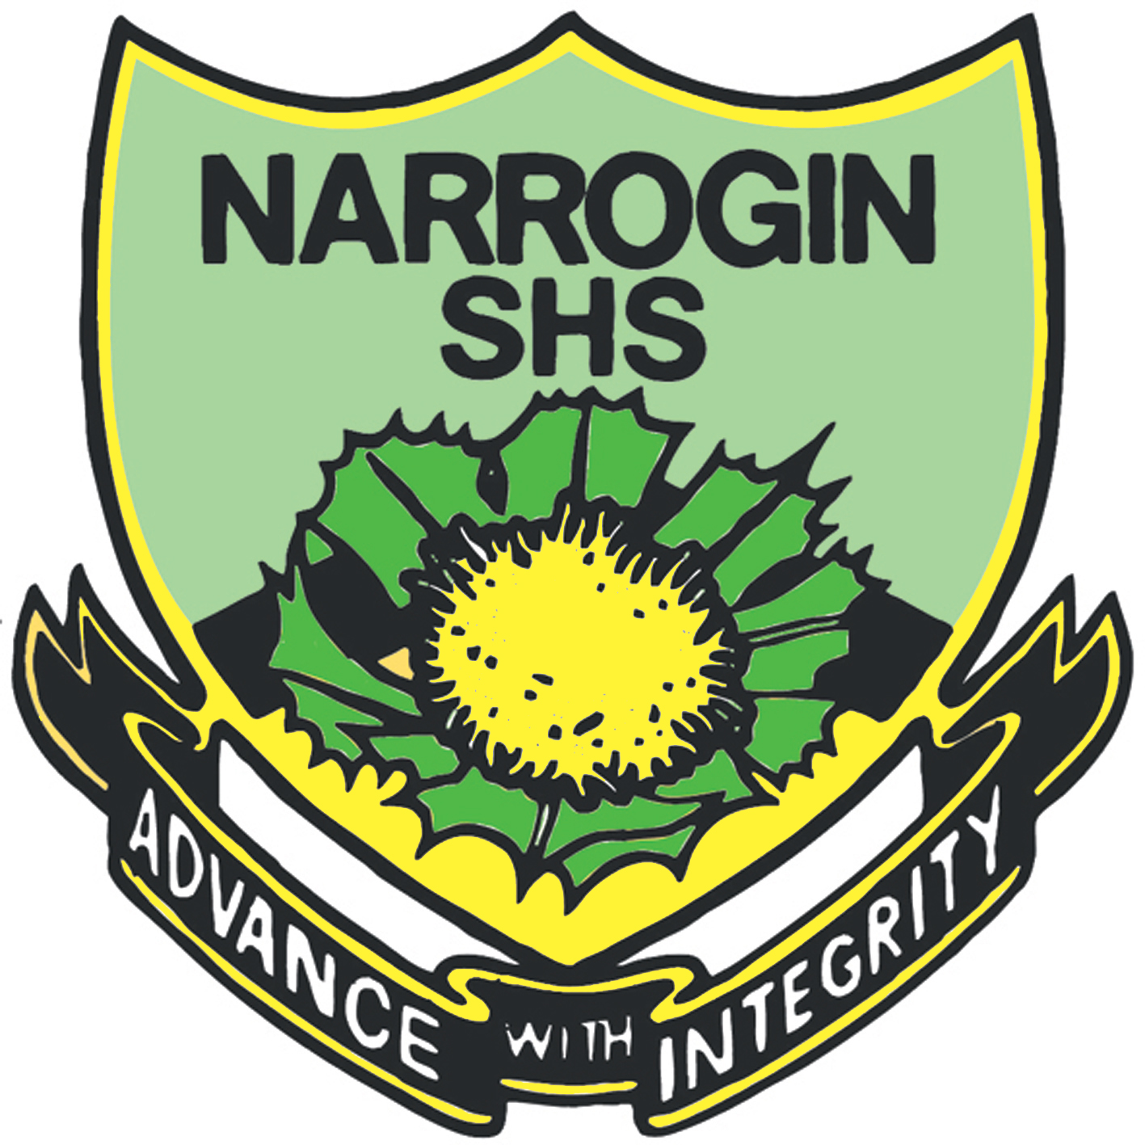 **2023 Chemistry 1 Test**

**Multiple Choice Answer Sheet**

**Name: ___________________ Year: 9**

**Multiple Choice – 20 questions.**

Circle your choice. If you change your mind, scrub your choice out and circle the one you want. If it is messy, clearly write your choice next to question.

1. A B C D

2. A B C D

3. A B C D

4. A B C D

5. A B C D

6. A B C D

7. A B C D

8. A B C D

9. A B C D

10. A B C D

11. A B C D

12. A B C D

13. A B C D

14. A B C D

15. A B C D

16. A B C D

17. A B C D

18. A B C D

19. A B C D

20. A B C D

Correct answers: ______ / 20 questions